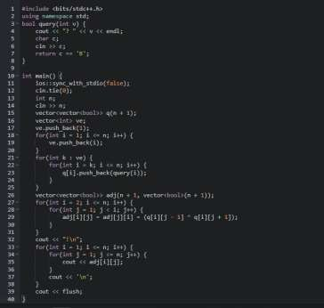

WORKSHEET 7

**Student Name:Priyansh Tyagi UID: 20BCS5670**

**DOMAIN CAMP:** 03-01-2023 to 14-01-2023 **Section/Group:** DWWC-43

**Subject Name:** IT Skills (DSA)

Question 1. KEYS AND ROOMS

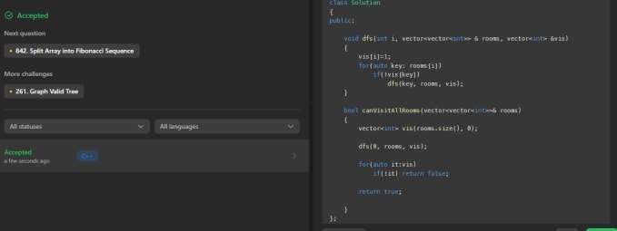

Question 2. HIDDEN COLORED GRAPH

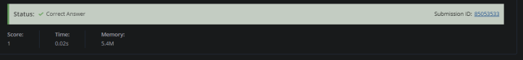**SOLUTION:**

Question 3. WINTER

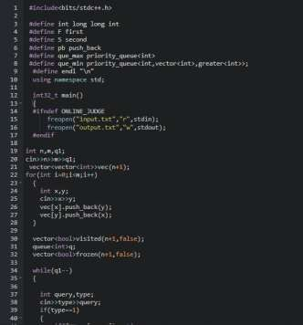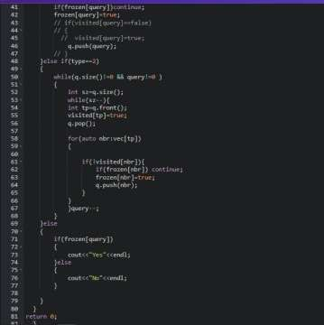

**SOLUTION:**

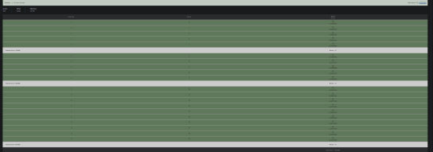

Question 4. MINIMAL TRAVEL TIME

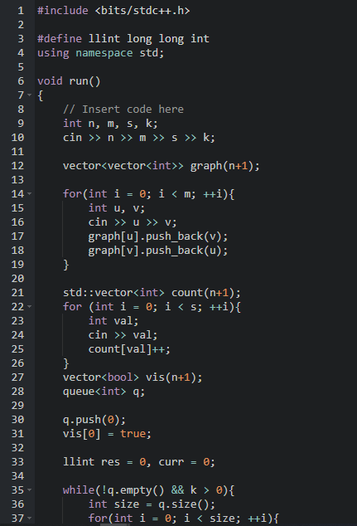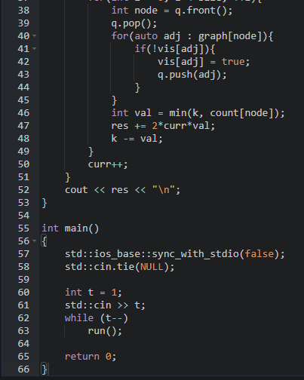

**SOLUTION:**

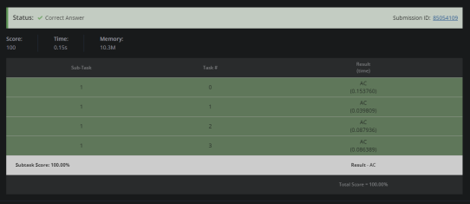

Question 5. CHEF AND REVERSING

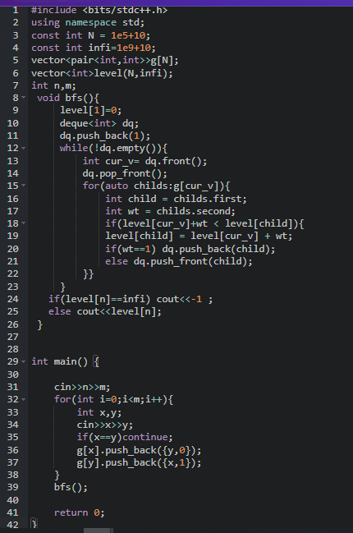

**SOLUTION:**

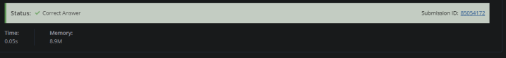

Question 6. CHEF AND EDGE FLIPPING

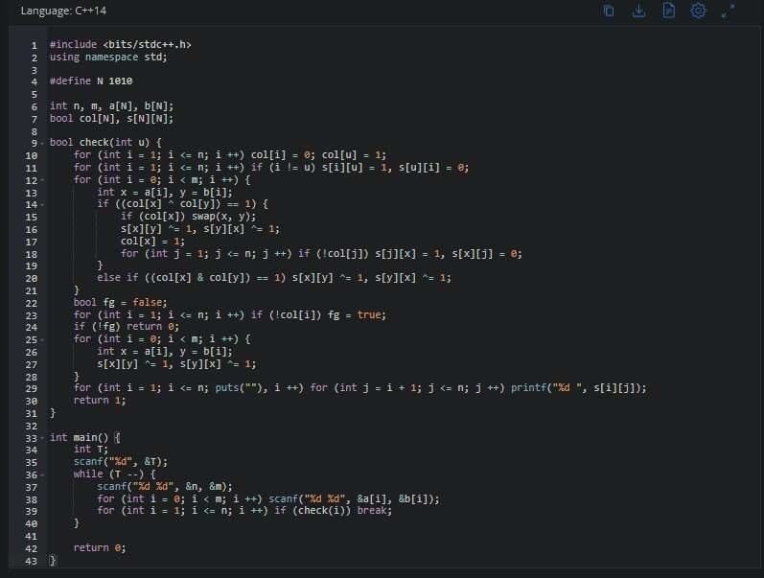

**SOLUTION:**

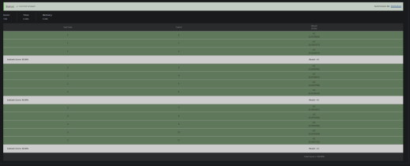

Question 7. MANGO MARKET

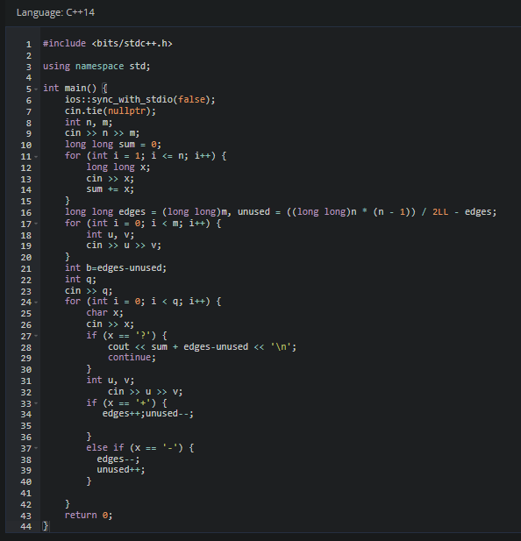

**SOLUTION:**

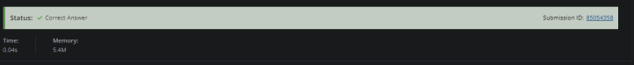

Question 8. ONE MORE WEIRD GAME

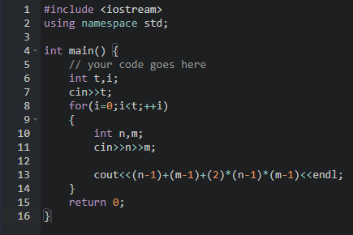

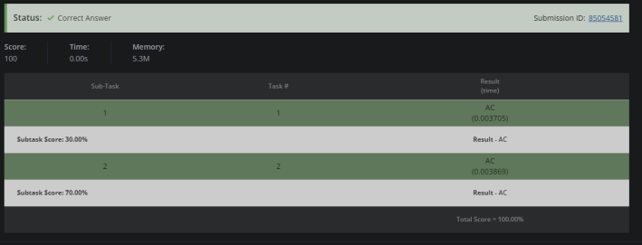**SOLUTION:**